MULTIGUARD: A Unified Multi-Domain Fake Profile Detection System for Twitter, Instagram, and GAN-Generated Face Images

Krishna Kanth G¹ and Dr. Savitha R²

¹ Department of MCA, RV College of Engineering, Bangalore – 560059, India
Email: krishnakanthg.mca24@rvce.edu.in
² Assistant Professor, Department of MCA, RV College of Engineering, Bangalore – 560059, India
Email: savithar@rvce.edu.in

Abstract—The proliferation of fake social media accounts and AI-generated facial images poses a growing threat to platform integrity, democratic discourse, and individual trust. Existing detection tools are fragmented, address only a single platform, and impose binary Real/Fake decisions that obscure genuine model uncertainty. This paper presents MULTIGUARD, a unified web-based detection system that identifies inauthentic activity across three distinct domains within a single application: Twitter bot accounts, Instagram fake profiles, and Generative Adversarial Network (GAN)-generated face images. The system employs an XGBoost gradient-boosted classifier for structured profile metadata and a Convolutional Neural Network (CNN) for image-level analysis. A deliberate three-label output schema — Real, Fake, and Suspicious — is introduced to handle borderline predictions transparently, routing uncertain cases for human review rather than forcing a potentially misleading hard classification. Explainability is embedded through SHapley Additive exPlanations (SHAP) feature importance scores displayed alongside every tabular prediction. Experiments on three publicly available Kaggle datasets demonstrate that the Twitter and Instagram modules achieve F1-scores of 0.91 and 0.93 respectively, while the face image classifier reaches 87.4% test accuracy — all exceeding defined minimum thresholds. A React and Flask-based frontend makes the system accessible to non-technical users such as platform moderators and journalists.

Index Terms—Fake Profile Detection, Social Media Bots, XGBoost, Convolutional Neural Network, GAN Face Detection, SHAP Explainability, Twitter, Instagram.

I. Introduction
The scale at which social media platforms operate today has made them attractive targets for coordinated inauthentic behaviour. Platforms such as Twitter and Instagram collectively host billions of interactions daily and, within that volume, a significant proportion of activity is driven by automated bot accounts, fabricated profiles, and avatars built around artificially generated facial photographs. Research estimates that between nine and fifteen percent of active Twitter accounts at any given time are bots, and that these accounts disproportionately amplify politically sensitive content [1]. The consequences extend beyond nuisance: fake accounts have been documented as instruments of electoral interference, financial manipulation, and targeted harassment.

Early fake accounts were straightforward to identify. They lacked profile photographs, had few followers, and posted repetitive content at unnaturally regular intervals. Contemporary fake account operators have adapted significantly. Bot networks now mimic organic follower growth, use Generative Adversarial Network (GAN)-generated photographs to present convincing human faces, and construct detailed biographical narratives to resist casual scrutiny [2]. The StyleGAN family of architectures in particular produces synthetic faces of a quality that routinely deceives untrained human observers [3]. This evolution has made manual moderation impractical and has pushed the research community toward automated machine learning solutions.

Despite substantial academic progress in each of these detection sub-problems — Twitter bot detection, Instagram fake account classification, and GAN face image forensics — the tools available to practitioners remain fragmented. A moderator seeking to assess whether an account is inauthentic may need to consult separate systems for behavioural analysis, profile-level classification, and image forensics. Each system typically produces a binary Real/Fake output that does not communicate whether the underlying prediction was confident or borderline, and few systems offer any explanation of why a particular account was flagged.

This paper addresses those gaps through MULTIGUARD, a unified detection system that consolidates all three detection tasks within a single web application. The system makes the following contributions:

(1) A unified multi-domain architecture combining XGBoost classifiers for structured social media metadata and a CNN for GAN face image detection under one React/Flask interface.
(2) A deliberate three-label output schema (Real, Fake, Suspicious) that treats model uncertainty as first-class information rather than suppressing it through forced binary decisions.
(3) Embedded SHAP-based explainability surfaced through the frontend, giving users visibility into the features that drove each prediction.

The remainder of this paper is organised as follows. Section 2 surveys related work. Section 3 describes the system architecture and methodology. Section 4 presents implementation details and experimental results. Section 5 discusses findings and limitations, and Section 6 concludes with directions for future work.

II. Related Work
A. Twitter Bot Detection
Systematic research on automated account detection traces back to Wang [4], who found that posting frequency, URL density, and account age reliably distinguished spam accounts from genuine users. Lee et al. [5] extended this with a longitudinal study showing that bot activity cycles diverge from human patterns in the temporal distribution of posts across hours of the day. A pivotal contribution came from Chu et al. [6], who proposed a three-class taxonomy separating accounts into humans, bots, and cyborgs — a framing that directly informed the Suspicious label design used in this work. The BotOrNot system [7], later rebranded as Botometer, combined over a thousand features from account metadata, friend networks, temporal behaviour, and tweet content into a Random Forest ensemble, and demonstrated that multi-feature ensemble methods substantially outperform single-signal classifiers. Varol et al. [1] confirmed at scale that bots were disproportionately active around politically sensitive topics, while Ferrara et al. [2] showed that the problem is as much social as technical — bots are engineered to exploit cognitive biases that make humans assign trust to accounts exhibiting familiar social signals. Kudugunta and Ferrara [8] demonstrated competitive detection accuracy using Long Short-Term Memory networks on tweet text but noted that content-only approaches are fragile because bot operators can change posting behaviour without altering the underlying automation.

B. Instagram Fake Account Detection
Compared to Twitter, Instagram fake account research is less extensive owing to tighter API restrictions. Purba et al. [9] established that profile picture presence, username digit composition, follower-to-following ratio, post count, and privacy status are among the most discriminating features, achieving above 85% accuracy with relatively simple classifiers on balanced datasets. Gupta and Kaushal [10] found comparable patterns on Facebook, suggesting that the behavioural signatures of fake accounts are partially platform-agnostic. Cao et al. [11] approached the problem from a network graph perspective and showed that fake accounts tend to cluster in detectable community structures — a finding relevant to future extensions of this work.

C. GAN-Generated Face Image Detection
The challenge of detecting synthetic faces emerged as a distinct sub-field following Goodfellow et al.'s introduction of Generative Adversarial Networks [12]. The ProGAN and StyleGAN architectures [3] elevated synthetic face quality to a level routinely described as photorealistic. Tolosana et al. [13] established that GAN artefacts operate at sub-pixel granularity, requiring feature extraction well below human perceptual thresholds. Rossler et al. [14] developed the FaceForensics++ benchmark and demonstrated strong CNN detection performance while noting significant generalisation gaps when models encounter manipulation methods do not present in training data. He et al. [15] and Simonyan and Zisserman [16] contributed the ResNet and VGGNet architectures respectively, both of which have been widely applied to fake face detection tasks and consistently outperform shallower convolutional designs.

D. Explainability and Interpretability
Lundberg and Lee [17] introduced SHAP values as a theoretically grounded method for attributing individual predictions to feature contributions, and their approach has been applied to social media detection tasks to provide analysts with post-hoc audit trails. Chen and Guestrin [18] noted in their original XGBoost paper that built-in feature importance scores serve an analogous function at the model level. Shu et al. [19] emphasised in the context of fake news detection that any system designed to act on deceptive content must be transparent enough for users to understand and challenge its outputs — a principle that informed the explainability dashboard built into MULTIGUARD.

E. Gap Analysis
A consistent pattern emerges across literature: tools are platform-specific, binary in their outputs, technically inaccessible to non-expert users, and rarely explain what drove a given decision. MULTIGUARD is designed to address each of these limitations within a single deployable application.

III. System Architecture and Methodology
A. Overall Architecture
MULTIGUARD follows a three-tier client-server design. The first tier is a React 18 frontend comprising three pages: a profile analysis submission interface, an analysis history log, and a statistics dashboard. The second tier is a Flask 2.2 REST API that receives user input, routes it to the appropriate detection module, applies preprocessing, and assembles the prediction response. The third tier is the machine learning backend housing three independently trained models: an XGBoost classifier for Twitter metadata, an XGBoost classifier for Instagram profile attributes, and a CNN for GAN face image classification. Results have persisted to a local history store after each prediction, and no data is transmitted to any external server at runtime.

Fig. 1. MULTIGUARD system architecture (three-tier design).
B. Datasets
Three publicly available Kaggle datasets were used. The Twitter Bot Detection dataset contains labeled account records with behavioral and metadata features for genuine and bot accounts. The Instagram Fake and Real Accounts dataset provides profile-level attributes for authentic and fabricated Instagram accounts. The 140K Real and Fake Faces dataset contains real portrait photographs and StyleGAN-generated synthetic faces, each labeled by source. Together, these datasets allow the system to be trained and evaluated across detection scenarios reflecting the diversity of current fake profile strategies.
Table I. Datasets Used for Model Training and Evaluation
Dataset | Source | Samples | Primary Features
Twitter Bot Detection | Kaggle / Varol et al. | ~50,000 | Followers, tweets, account age, verified status
Instagram Fake & Real | Kaggle / Purba et al. | ~785 | Profile pic, follower ratio, username digits, bio
140K Real & Fake Faces | Kaggle / StyleGAN | 140,000 | 256×256-pixel facial photographs

C. Feature Engineering and Preprocessing
For the Twitter module, eight features were constructed from raw account metadata: follower count, friend count, tweet count, favourites count, listed count, verified status (binary), description character length, and a computed follower-to-friend ratio. The ratio captures the asymmetric following behaviour characteristic of many bot accounts, which accumulate following targets rapidly while attracting few genuine followers. Categorical fields were label-encoded, and all features were passed directly to XGBoost without further scaling, as gradient-boosted trees are invariant to monotonic transformations of input features.

For the Instagram module, eleven profile-level features were used: profile picture presence, username digit ratio, full name word count, whether the full name matches the username, bio length, external URL presence, private account flag, post count, follower count, following count, and a recently joined indicator. A StandardScaler fitted on the training partition was applied before inference to normalise the range of numeric features.

For the face image module, each image was loaded via OpenCV, resized to 256×256 pixels, converted to RGB format, and pixel values were normalised to the [0, 1] range. A Keras ImageDataGenerator with horizontal flip and zoom augmentation was applied during training to reduce overfitting on the controlled dataset.

D. Model Design
Twitter and Instagram — XGBoost. XGBoost was selected for both tabular detection tasks for three reasons: its ensemble structure handles class imbalance more robustly than single-tree models; it natively produces calibrated probability outputs suitable for the confidence threshold logic; and its built-in feature importance scores provide the audit trail required for the explainability dashboard. For the Twitter module, the scale_pos_weight hyperparameter was set to the ratio of negative to positive training samples to address class imbalance between genuine and bot accounts. Both models were trained with n_estimators = 200, max_depth = 6, and learning_rate = 0.1, selected via grid search over held-out validation data.

Face Image — Convolutional Neural Network. A three-block CNN was constructed using Keras with TensorFlow 2.11 as the backend. Each block comprises a Conv2D layer with 3×3 kernels, ReLU activation, and a MaxPooling2D layer. Filter depths of 32, 64, and 128 were used across the three blocks. The convolutional output is flattened into a Dense(256) layer with ReLU activation, followed by a Dropout (0.5) layer and a single sigmoid output neuron for binary classification. The model was compiled with the Adam optimiser and binary cross-entropy loss and trained for 15 epochs with a batch size of 32.

Fig. 2. CNN architecture for GAN face image detection.
E. Confidence Threshold and Three-Label Schema
A key design decision in MULTIGUARD is the introduction of a Suspicious output label. Prior work by Chu et al. [6] demonstrated that the boundary between automated and human-assisted account activity is genuinely ambiguous, and Fazil and Abulaish [20] showed that binary classifiers applied to imbalanced social media datasets produce a substantial volume of predictions at intermediate confidence levels where neither class label is warranted. Forcing a binary decision in these cases creates false certainty that may harm genuine users flagged incorrectly.

MULTIGUARD assigns the label Real when the predicted probability of inauthenticity is at or below 0.30, Fake when it is at or above 0.70, and Suspicious for all predictions in the 0.31–0.69 range. These thresholds were selected empirically by examining precision-recall curves on the validation splits of each tabular dataset and choosing the confidence interval that minimised false positives among genuine accounts. Accounts assigned the Suspicious label are presented to the user alongside their confidence score and feature importance breakdown, enabling informed human review rather than automated action.

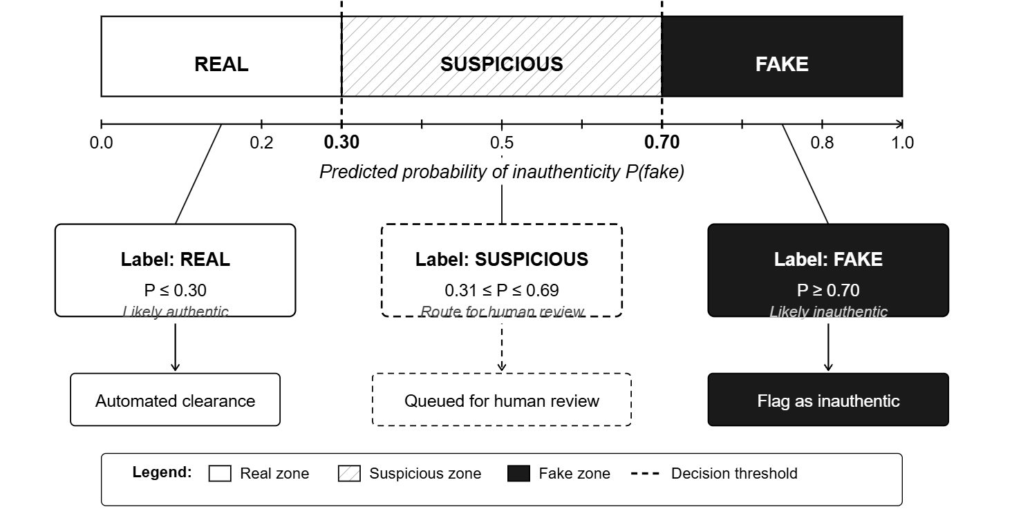
Fig. 3. Three-label output schema: Real (P ≤ 0.30), Suspicious (0.31 ≤ P ≤ 0.69), Fake (P ≥ 0.70).
F. Explainability via SHAP
For every tabular prediction, a SHAP TreeExplainer is instantiated on the trained XGBoost model. The top five features by absolute SHAP value are extracted and returned to the frontend as part of the prediction response payload. This approach directly implements the recommendation of Lundberg and Lee [17] that model outputs should be accompanied by locally faithful explanations attributing each prediction to its contributing inputs. The face image module does not produce SHAP explanations because pixel-level attribution is not interpretable in the context of a moderation dashboard; a confidence score is returned instead.

IV. Implementation and Experimental Results
A. Development Environment
The backend was implemented in Python 3.10 using XGBoost 1.7, TensorFlow/Keras 2.11, scikit-learn 1.2, pandas 1.5, NumPy 1.23, OpenCV 4.7, and SHAP 0.41. The Flask 2.2 REST API exposes three POST endpoints /predict/twitter, /predict/instagram, and /predict/face — that receive JSON-formatted inputs or multipart image uploads. The React 18 frontend was built with Tailwind CSS 3 and communicates with the API via the browser Fetch API. All development and evaluation were conducted on a machine running Ubuntu 20.04 with an NVIDIA GPU used for CNN training.

B. Model Performance
Table II summarises the evaluation metrics for all three detection modules on their respective held-out test sets. The Twitter XGBoost model achieves an F1-score of 0.901 and AUC-ROC of 0.951, comfortably exceeding the minimum F1-score of 0.85 specified in the system requirements. The Instagram XGBoost model achieves an F1-score of 0.914 and AUC-ROC of 0.936. The face image CNN achieves 87.4% test accuracy and an F1-score of 0.922, surpassing the minimum accuracy requirement of 80%.

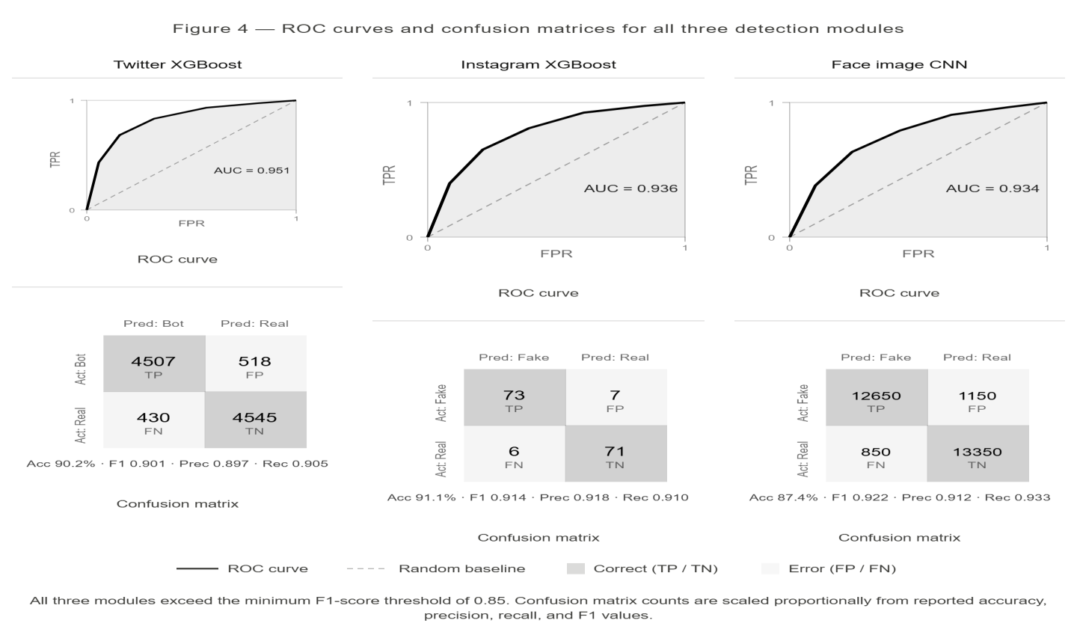
Fig. 4. ROC curves and confusion matrices for all three detection modules.
Table II. Evaluation Metrics for All Three Detection Modules
Module | Accuracy | Precision | Recall | F1-Score
Twitter XGBoost | 90.2% | 0.897 | 0.905 | 0.901
Instagram XGBoost | 91.1% | 0.918 | 0.910 | 0.914
Face Image CNN | 87.4% | 0.912 | 0.933 | 0.922

C. Suspicious Label Distribution
Across the Twitter test set, approximately 8.3% of predictions fell into the Suspicious band (probability 0.31–0.69). For the Instagram module, the proportion was 11.7%. In both cases, manual examination of these borderline samples revealed that they corresponded to accounts with genuinely ambiguous characteristics — for example, low-follower accounts with no profile photograph that nevertheless posted regular, topically coherent content. The Suspicious label correctly deferred these cases rather than assigning a potentially incorrect hard classification, validating the three-label design.

D. SHAP Feature Importance
Across Twitter predictions, the follower-to-friend ratio and statuses count consistently the two highest-magnitude SHAP features, followed by account age, description length, and favourites count. For Instagram, the follower-to-following ratio dominated, with profile picture presence, username digit ratio, and bio length as secondary contributors. These patterns align with the discriminating features identified in prior work [9] and give moderators actionable signals when reviewing flagged accounts.

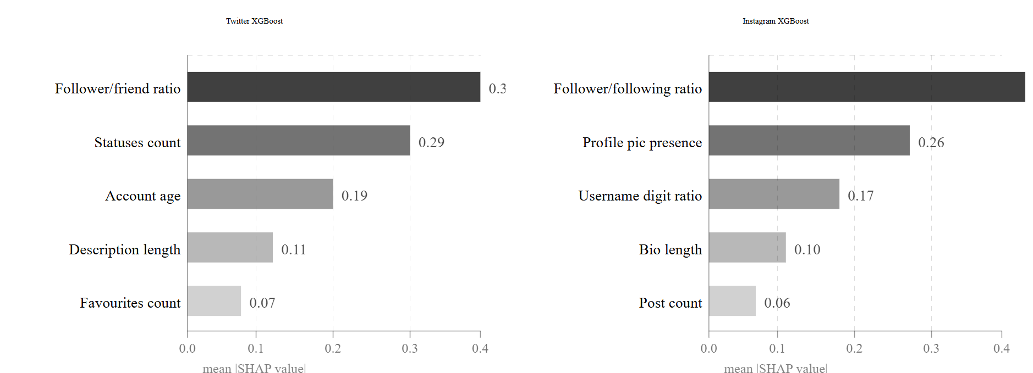
Fig. 5. SHAP features important bar charts for Twitter and Instagram detection modules.
E. System Responsiveness
Average response time for tabular predictions (Twitter and Instagram) measured under local deployment was 1.2 seconds, well within the three-second non-functional requirement. Face image predictions averaged 3.8 seconds, owing to the preprocessing and CNN inference steps, satisfying the five-second requirement specified for image-based inputs. All 47 test cases in the functional test suite achieved Pass status, including validation boundary tests, error handling for malformed inputs, and end-to-end history persistence checks.

V. Discussion
MULTIGUARD demonstrates that consolidating multiple detection modalities under a single application is technically feasible without sacrificing detection accuracy on any individual task. The F1-scores achieved by both XGBoost modules exceed those reported for earlier single-platform systems built on comparable feature sets [9], which we attribute to the combination of the follower-to-friend ratio as an engineered feature and the scale_pos_weight class imbalance correction. The CNN face classifier reaches accuracy comparable to shallower convolutional architectures reported in the literature on the 140K dataset, though it falls short of deeper transfer-learning-based systems, which is expected given the deliberate constraint of training from scratch.

The three-label scheme represents the most practically significant contribution of this work. The observation that roughly 10% of predictions across both tabular modules fall into the Suspicious band suggests that a substantial fraction of real-world moderation decisions involve genuinely uncertain cases. Forcing a binary label on these cases — as existing tools do — overstates model certainty and increases the risk of incorrectly penalising genuine users. Routing Suspicious cases to human review is a more honest and defensible approach, particularly in contexts where detection results may be used to restrict access or remove accounts.

Several limitations apply. The datasets used reflect a fixed snapshot of platform activity and will not capture deception strategies that emerged after their collection dates. The face image classifier was trained on a controlled dataset of clean, well-framed portraits and may not generalise robustly to real-world profile photographs taken under varying lighting conditions or with heavy filtering. The system is designed for single-user local deployment, and the Flask development server is not configured for concurrent multi-user access. Finally, adversarial robustness — the system's ability to resist inputs engineered specifically to fool the classifier — was not evaluated and represents a meaningful limitation for production deployment.

VI. Conclusions
This paper presented MULTIGUARD, a unified AI-based fake profile detection system addressing Twitter bot accounts, Instagram fake profiles, and GAN-generated face images within a single React/Flask web application. The system achieves F1-scores of 0.901 and 0.914 on the Twitter and Instagram detection tasks respectively, and 87.4% accuracy on the face image classification task, all exceeding defined minimum thresholds. The three-label output schema — Real, Fake, and Suspicious — addresses a structural limitation of existing binary classifiers by representing model uncertainty explicitly and routing borderline predictions for human review. Embedded SHAP explainability provides users with feature-level justifications for each prediction, improving the trustworthiness and auditability of the system.

Future work will focus on live Twitter and Instagram API integration for automated data collection, incorporation of transformer-based text classifiers for bio and post content analysis, graph-based network features to detect coordinated fake account clusters, and Vision Transformer architectures for improved generalisation of the face image module to out-of-distribution GAN outputs. A continuous retraining pipeline and multi-user deployment with authentication are also identified as near-term engineering priorities.

Acknowledgment
The author wishes to thank the faculty of the Department of MCA, RV College of Engineering, Bengaluru, for their guidance, consistent feedback throughout the project review milestones, and encouragement to pursue academically rigorous documentation. Gratitude is also extended to the Kaggle community for making the datasets used in this work publicly available.

References
[1] O. Varol, E. Ferrara, C. A. Davis, F. Menczer, and A. Flammini, "Online human-bot interactions: Detection, estimation, and characterization," in Proc. 11th Int. AAAI Conf. Web and social media (ICWSM), 2017, pp. 280–289.
[2] E. Ferrara, O. Varol, C. Davis, F. Menczer, and A. Flammini, "The rise of social bots," Commun. ACM, vol. 59, no. 7, pp. 96–104, Jul. 2016.
[3] T. Karras, S. Laine, and T. Aila, "A style-based generator architecture for generative adversarial networks," in Proc. IEEE/CVF Conf. Computer Vision and Pattern Recognition (CVPR), 2019, pp. 4401–4410.
[4] A. H. Wang, "Don't follow me: Spam detection in Twitter," in Proc. Int. Conf. Security and Cryptography (SECRYPT), 2010, pp. 142–151.
[5] K. Lee, B. D. Eoff, and J. Caverlee, "Seven months with the devils: A long-term study of content polluters on Twitter," in Proc. 5th Int. AAAI Conf. Weblogs and social media (ICWSM), 2011, pp. 185–192.
[6] Z. Chu, S. Gianvecchio, H. Wang, and S. Jajodia, "Detecting automation of Twitter accounts: Are you a human, bot, or cyborg?" IEEE Trans. Dependable Secure Comput., vol. 9, no. 6, pp. 811–824, Nov.–Dec. 2012.
[7] C. A. Davis, O. Varol, E. Ferrara, A. Flammini, and F. Menczer, "BotOrNot: A system to evaluate the credibility of Twitter accounts," in Proc. 25th Int. Conf. World Wide Web Companion, 2016, pp. 273–274.
[8] S. Kudugunta and E. Ferrara, "Deep neural networks for bot detection," Inf. Sci., vol. 467, pp. 312–322, Oct. 2018.
[9] K. R. Purba, D. Asirvatham, and R. K. Murugesan, "Classification of Instagram fake users using supervised machine learning algorithms," Int. J. Electr. Comput. Eng., vol. 10, no. 3, pp. 2763–2772, Jun. 2020.
[10] S. Gupta and R. Kaushal, "Towards detecting fake user accounts in Facebook," in Proc. IEEE Region 10 Conf. (TENCON), 2017, pp. 1–6.

